Putney

Date | 17th April 2018
Document Owner | Pete Mellar

Reviewed & Approved by
Organisation | Name | Signed
South Western Railway | Chico Coulibaly
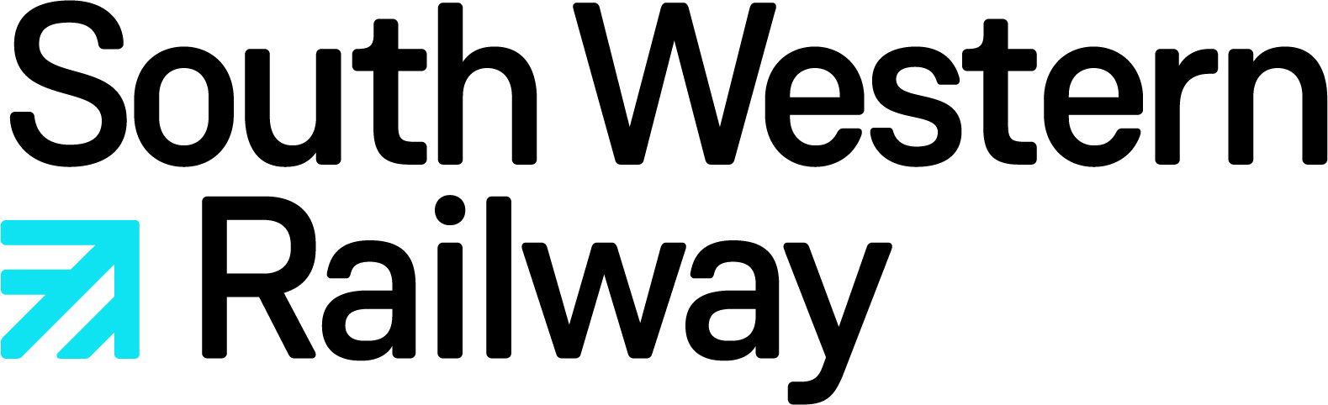

Contents

INTRODUCTION 3
COLLEAGUE WELFARE & VOLUNTEERS 4
OVERALL COMMUNICATIONS 5
COMMUNICATION WITH CONTROL 6
LOCAL COMMUNICATIONS 7
PRACTICAL OPERATION OF THE STATION 8
ALTERNATIVE TRANSPORT 10
CSL2 OVERVIEW 11
USEFUL WEBSITES & TOOLS 12
TOP TIPS FOR THIS STATION 13
ROLE ABBREVIATIONS YOU MAY HEAR 14
ROLE DESCRIPTIONS 15

INTRODUCTION

This Station Disruption Plan has been created to help you assist customers at this location during disruption. We know from what our customers tell us that the information they receive when trains are severely delayed is a big contributor to their overall customer experience on our network.

Working on our stations during disruption can be a challenge at times and your help with providing our customers with as much useful information as possible about the alternatives that might be available to them is really appreciated. This plan contains all you need to know about managing disruption at this location which is particularly important for those who do not normally work at this station.

This plan should be used in conjunction with other plans including the Station Emergency Plan and Crowd Control plans where they exist.

It is important that we keep this document up to date; therefore, if you become aware of a change to alternative transport options or have a suggestion for what else could be included, then please let the owning Station Manager know so this can be updated at an appropriate time.

Thank you for all that you do for our customers during disruption.

South Western Railway

COLLEAGUE WELFARE & VOLUNTEERS

Depending on the need, additional support will be requested via the Level 2 On Call Manager through control. The manager responsible for this station will then ensure that any volunteers are briefed on their arrival using the Site Specific Brief for the location along with any other local information, the nature of the disruption and any alternative travel arrangements that have been put in place.

Risk Factors to consider during disruption:

Hot Weather
- If prolonged disruption occurs during hot weather, it will be necessary for customer and colleague welfare to provide water at key locations. This should be arranged via station colleagues and through the on call structure.
Colleague Breaks
- During prolonged disruption it is important for the welfare of station colleagues and volunteers to ensure that all are receiving adequate breaks during their shifts (including any managers who are coordinating or assisting the coordination of plans). It is the responsibility of the Level 1 On Call Manager to liaise with the station manager to ensure that this is being achieved. If there is a reduction of the train service it is expected that teams should manage their breaks as best as possible. Colleagues should let their line manager or on call manager know if this is not possible.
- Please try to ensure breaks are taken away from the view of customers. This will also ensure you have as much of an uninterrupted break as is possible.
- Also consider how long you have been working for. If you feel the effects of fatigue you should highlight this immediately so cover for the role you are performing can be arranged.
Colleague Safety
- Always remember to consider your safety as well as that of others.
- Many situations can be dealt with well through a calm approach so if you are approached by a frustrated customer please remain calm, polite and respectful at all times.
- If required you should politely excuse yourself and make your way to a position of safety and request assistance which may be from a colleague in the first instance or BTP (if appropriate for the circumstances).
- For further guidance, please refer to the policy on Reducing Violence At Work.

OVERALL COMMUNICATIONS

When our control centre receives initial notifications of incidents, the information is then passed to our information controller. They hold the responsibility of communicating the initial information which will be a disruption warning or holding message. We aim to send an initial message within 10 minutes of any incident that takes place.
We use a consistent style of messaging which will show 3 key pieces of information.
- the cause of disruption: what the problem is, and where it is
- the impact it will have: what this means for the journey
- and our advice: how to continue the journey

We have a long-term and comprehensive on-call manager structure which we activate during periods of significant disruption. This includes station, guards, drivers, fleet and senior managers along with directors.
Through their team, the Route Control Manager takes responsibility for mobilising our on-call teams and our Train Operator Liaison Officer (TOLO)-trained managers where required.
Our Customer Information System is managed by our Local Information Controllers, both at our Control Centre and at Station Control Points located around the network.
The Tyrell system updates our own JourneyCheck site, ensuring that whether you are looking for a ticket or making a final check before starting out on your journey, you can get the latest information about an incident.
We aim to put train alteration messages into the system as soon as we receive them.
In addition during each on call week, each level 2 on call manager will set up a whatsapp group for level 1 managers and the Information Team Leader. From these who will filter relevant information down to the level 1 on call managers who in turn will send this information on to local station colleagues.
More detailed information can be found within the Passenger Information During Disruption standard.

COMMUNICATION WITH CONTROL

Information Flow During Disruption

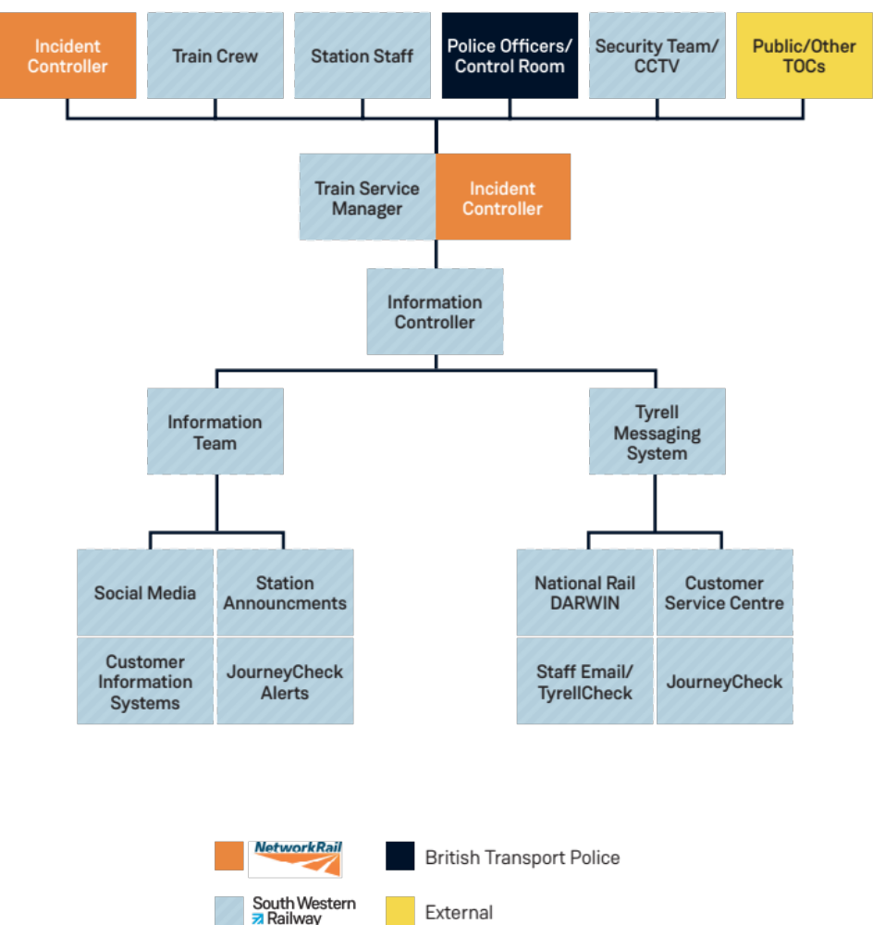

LOCAL COMMUNICATIONS

Local station communications with our customers should be managed proactively using regular station announcements in advance if possible. We know that station announcements are received well by our customers so it is important that we provide as much information as possible. If there is no information to provide at the time, this should be relayed to customers so they are kept up to date. If there are any issues with the equipment at this station, it should be faulted immediately.
Remember, if there is a mobile mic at this station; please make sure it is used proactively so as to make sure our customers are kept up to date with whatever we know.
Local Whatsapp groups are a good way of sharing information between stations and are encouraged in order to provide as much information to customers as possible4 Support for

SUPPORT FOR OTHER STATIONS

Below is a list of stations that this station may be in a position to support during disruption.

Station Name | Telephone Number | Times
Wandsworth Town | 07920 870 139 | Peak times only
Barnes | 02079 040 399 | Peak times only

PRACTICAL OPERATION OF THE STATION

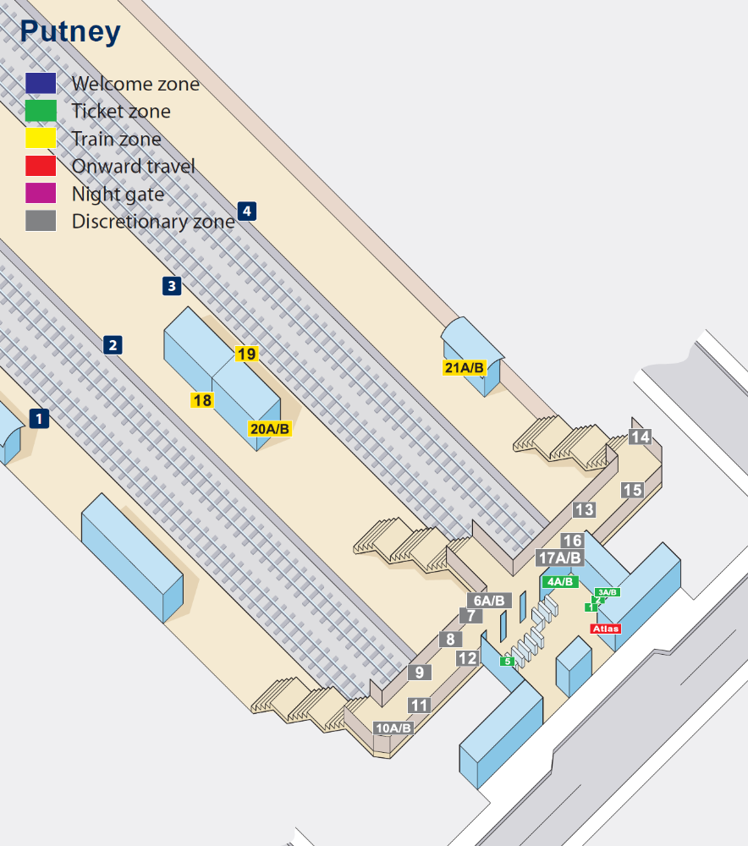

GATELINES

Gatelines should be kept in operation at all times unless there is an emergency. Gatelines provide an effective way of managing the flow of people in and out of stations. Gatelines also provide a dedicated person at the entrance to the station to advise of any issues with the train service so customers can make alternative arrangements if necessary.
If the gate does need to be opened it must be recorded in the gateline log.

STATION EMERGENCY PLAN

This document contains details of the emergency arrangements for this location including local hospitals, evacuation routes and muster points. The document can be found on the Health & Safety Noticeboard.
All colleagues are required to familiarise themselves with this document and seek advice from their line manager if there are any questions.

TICKET ACCEPTANCE
When services are severely disrupted we can sometimes arrange for passengers to use an alternative route to complete their journey. Where this involves the use of other train/bus operators SWR will obtain agreement from them to allow customers to use these routes at no extra cost. This can also include travel arrangements for the following day if appropriate.
The majority of these agreements come into place automatically when we declare CSL2 status for an incident; agreements with Cross Country, local bus operators and London Buses are made by agreement between our control room and theirs only.
Alternative routes that are agreed will be communicated via the information team through emails, phone calls or our information systems during each incident.
In addition, there may be easements agreed for car parking arrangements which will be agreed and communicated at either the same time or shortly after.

ALTERNATIVE TRANSPORT

Please see below for a selection of alternative routes that can be taken from this station. It cannot be assumed that ticket acceptance is in place on these alternative routes. Therefore this must be checked first.

Route Available (Rail) | Destination | Route Available (Bus) | Walking Routes  (if applicable)
Putney East | Underground District line
SWR | Barnes/New Malden/ Tolworth | 265
SWR | Clapham Junction / Richmond | 337 / 37 / 39
SWR | Earlsfield | 270
SWR | Kingston / Norbiton | 85
SWR | Wimbledon | 93

CSL2 OVERVIEW

The table below details the disruption thresholds used by Control.
These should be used as guidance when responding to disruption.

 | Criteria
SWR Status Definitions | Metro Routes | Suburban Routes / Branch Lines | Mainline Routes
Green Good Service | Isolated incident delaying up to 2 trains by less than 5 minutes  If degraded working level 1 or 2 (D1/D2 status) is in place on service close, customer messaging will remain active  Any incident not affecting services (e.g. overnight) but with potential to impact trains when service resumes
Yellow Minor Delays CSL2 Optional | OFF-PEAK: Incident expected to delay less than 15 trains by less than 15 minutes  PEAK: Incident expected to delay less than 10 trains by less than 5 minutes  3 or more alterations/cancellations on the same route due to a single incident  Any major disruption issue affecting 2 or more TfL routes interchanging with South Western Railway Stations | More than 3 services running between 5 and 15 minutes late  3 or more alterations/cancellations on the same route due to a single incident | More than 3 services running between 5 and 25 minutes late  3 or more alterations/cancellations on the same route due to a single incident
Red Major Disruption CSL2 Mandatory | OFF-PEAK: Incident expected to delay 15 or more trains by 15 minutes or more  Incident expected to delay services by more than 15 minutes  PEAK: Incident expected to delay 10 or more trains by 5 minutes (in line with customer flow)  Incident expected to delay services by more than 5 minutes (in line with customer flow)  or more alterations /cancellations on a core route  Any closure of 1 or more lines (e.g. UMSL, UMFL), on a Core Route in peak times | More than 5 services running more than 15 minutes late  Consistent alterations/cancellations to services on one line | More than 5 services running more than 25 minutes late  Consistent alteration/cancellations to services on one line
Red Major Disruption CSL2 Mandatory | Any instance of evacuation from a train not at a station  Any implementation of crowd control measures at a category A or B station  Any closure of a category A or B station or attached TfL facilities  Core Route blocked in either direction between the start of service and 0000  Any large-scale TfL service suspension involving 4 or more lines intersecting with South Western Railway stations  Any train trapped not at a platform >20 minutes  Any loss of third rail power supply  Any other route blocked with no alternative transport option available  Loss of 20% of capacity during morning/evening peak on any core route
Black CSL Mandatory  “Do Not Travel” Considered | Service Suspension  An infrequent incident that causes widespread delays resulting in extensive parts of the network becoming unavailable (examples would be terrorist and weather related events)

USEFUL WEBSITES & TOOLS

Website Name | Website Address | What do we use it for?
Tyrell Check | https://www.tyrellcheck.com/SWR/messages | Service information from Network Rail, SWR and other TOCS. Details disruption across the network as well as advise on ticket easements etc. (set filters to pick up messages about other operators)
P2 | Not web based, but can set up on a computer | Allows you to visually see trains moving across our network and can be set up for your specific station to show station line ups.
TRUST | Not web based, but can set up on your computer | Many things available here including planning journeys and checking train configurations.
National Rail Enquiries | http://www.nationalrail.co.uk/ | Allows you to plan journeys, and check facilities at other stations
Tube Planner | http://www.tubeplanner.com/ | Journey planner for the Underground
Open Train Times | http://www.opentraintimes.com/maps | Displays real time track maps
CCLDB | realtime.nationalrail.co.uk/ccldb | Displays real time train information within Darwin
PPM | Realtimeflow.co.uk.ppm | Provides public performance information

If you are aware of issues with your train information on stations, please make your local SCP aware (if you have one) as they will be able to help by updating the screens as appropriate.
If you don’t have an SCP you should contact the local information controllers in the WICC who will be able to help.
If you still need help after this, you should contact your local manager or on level 1 call manager aware so they can assist.

TOP TIPS FOR THIS STATION

Issue | Tip
If there is service disruption on the SWR line | Waking distance to East Putney
 | Change at Westminster for London Waterloo
 | Change at West Brompton for Clapham Junction

ROLE ABBREVIATIONS YOU MAY HEAR

CSA | Customer Service Assistant
RO | Rail Operator
CO | Clerical Officer
CA | Customer Ambassador
TP | Train Presentation
RPA / RPI | Revenue Protection Assistant / Inspector
RCO | Rail Community Officer
DSM | Duty Station Manager
FSM | Flagship Station Manager
SM | Station Manager
NR | Network Rail
Person in charge (PIC) | The person responsible for managing an emergency response and carrying out the requirements of this Plan. Usually the Station Manager (SM) or Duty Station Manager (DSM) unless another person has been nominated by the Station Manager
RIO | Rail Incident Officer
SIO | Station Incident Officer
TOLO | Train Operator’s Liaison Officer
SWR | South Western Railway
BTP | British Transport Police

ROLE DESCRIPTIONS

Responding Manager – any rail manager who is responsible for providing the initial response to an incident. They may be either on duty at work or on call during out of hours.

Level 1 On Call Manager (Stations) - is responsible for the area this station is located in. This person will keep an overview of the whole area and will pass on information as required. This person will also have direct contact with the Level 2 On Call Manager for escalation purposes

Level 2 On Call Manager (Customer Service) - is responsible for keeping an overview of the South Western Railway in general and for ensuring we are doing all we can to operate safely whilst giving the best customer experience possible.

Senior On Call (SWR) – provides Senior Management cover for the business and provides support to the Route Control Manager for incidents that need a strategic level of management. They are also the communications link with the Director on call.

Station Incident Officer/Person In Charge - the competent person appointed by the SWR to manage and co-ordinate the response to incidents affecting station operations. Where there is no RIO on site the Station Incident Officer will act as the focal point for the external response agencies. Where an RIO is appointed, the Station Incident Officer will operate in a supporting capacity, managing the station element of the incident site.

Flagship/Duty/Station Manager - is the owning manager of this station and will be the local manager responsible for it’s safe operation including the management of any crowding, customer experience and accurate information to customers. Depending on the situation, they may or may not be on site at the time. If this is the case, the relevant level 1 on call manager will be responsible for this station working with any station colleagues.

Station Colleagues - are responsible for ensuring the station is operating safely and that customers are provided as much information as possible during disruption. These colleagues may well liaise with the level 1 on call manager to provide and receive information in order to assist customers and to highlight any local risks.

Rail Community Officers - will generally assist at stations (if available). Their attendance will be communicated through the on call structure.

Route Control Manager – is responsible for managing the day-to-day provision of service, covering everything from signaling and railway track, to managing our joint response to disruption. The RCM also holds responsibility for monitoring the overall train service, and Service Delivery Manager to decide how we can best bring services back to normal running during disruption.
Information and Customer Experience Manager – is responsible for managing the team who pass information to our ground teams and our customers, including internal messaging systems, customer information screens on the network, train service information, and social media.

Information Team Leader - responsible for managing customer service information, including giving notice of ticket office closures, and monitoring our network of Ticket Vending Machines. Leads our team of Local Information Controllers

Information Controller – is responsible for managing the flow of operational information, keeps our website updated and arranges ticket acceptance with other train operators when disruption affects services.
Incident Controller – is the first point of call for infrastructure teams and Network Rail response specialists during disruption. They will organise and monitor our resources in order to help us resolve any issues.
Train Service Manager - controls the train service in each part of the network, and is responsible for managing the train service during disruption.
Duty Resource Manager – is responsible for managing our train crews through normal service and during disruption, including allocating any reserve crew members to services during disruption.

